Notes 03 - Data Import and Wrangling

STS 2300 (Spring 2024)

Updated: 2024-09-07

Table of Contents

Reading for Notes 03 1

Learning Goals for Notes 03 1

Importing data into R 1

The Pipe Operator (%>%) 1

Subsetting data by rows and columns 1

Using filter() to select rows meeting a condition 1

Using select() to choose only certain columns 1

Using mutate() to create new variables 1

Long vs. Wide Data 1

Revisiting the Learning Goals for Notes 03 1

# Reading for Notes 03

Read [Section 4.1 of ModernDive](https://moderndive.com/4-tidy.html#csv) to learn about importing data from URLs and using the RStudio interface.

Read the [Chapter 3 of ModernDive](https://moderndive.com/3-wrangling.html) to learn more about data wrangling.

# Learning Goals for Notes 03

* Be able to use R Studio to generate code for importing data of various types into R.
* Understand the usefulness of the pipe operator and be able to write multi-step code using it.
* Be able to subset data frames by rows and columns as desired.
* Be able to create new variables to add to a data frame.
* Understand the difference between wide and long format data and be able to convert between the two types.

# Importing data into R

There are *many* ways to import data into R, and several functions have been created to make the process easier for different types of data. In STS 2300, we will focus on how to use the “Import Dataset” option in the Environment section. This will allow us to view a preview of the data and choose options as we go. This option also produces code so that we can read the data in the exact same way the next time without going through the menu options again.

Before importing data, I encourage you to put the data in the same folder as your R script and then do the following:

Session –> Set Working Directory –> To Source File Location

This will make it so that the file path for the data is not specific to your computer and will allow others to run the same code.

Let’s try this out in our **notes03.R** file. Download the **NC Bridges.csv** file and put it in the same folder as your **notes03.R** file. Then go to Import Dataset and choose **From Text (readr)**. This option works well for .csv files.

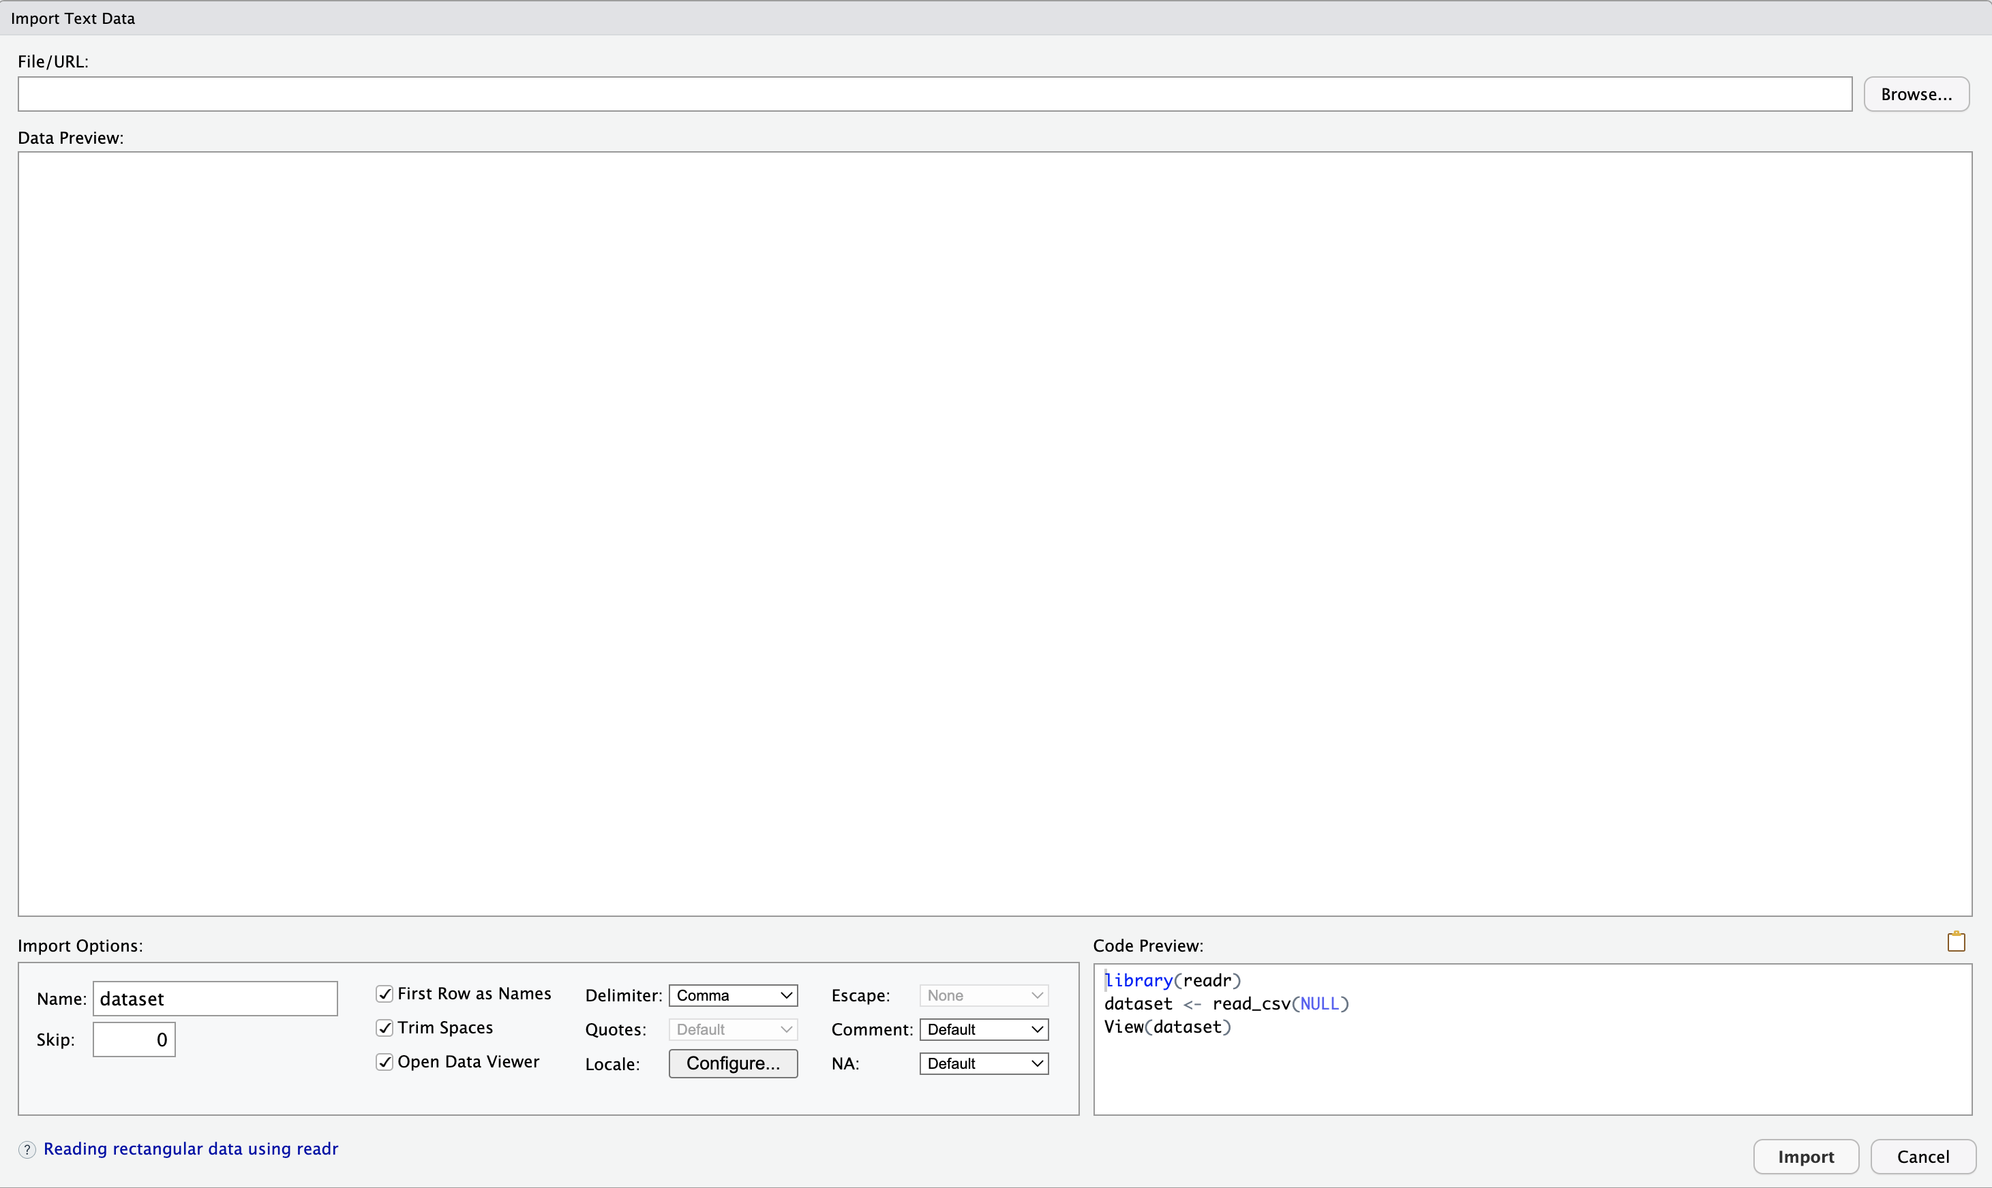

Import Dataset Screen

We can click **Browse…** to find the data. Once we do that, a preview will show up in the big screen in the middle. On the bottom left are options we can change, and on the bottom right is code that will read the data into R. Before you hit **Import** be sure to copy the code that is produced so that you can add it to an R script for future use.

Use the space below to add notes about reading in data this way.

# The Pipe Operator (%>%)

[Section 3.1](https://moderndive.com/3-wrangling.html#piping) of the textbook talks about the symbol %>%, which we call the pipe operator (like how <- is the assignment operator). The pipe operator is useful when we want to perform a series of actions on a data frame. It’s main purpose is to take an object on the left and “pipe it into” a function on the right.

**Note**: There are actually **two** pipe operators now. In some places, you may see |> used instead of %>%. For example, our supplementary textbook [R for Data Science](https://r4ds.hadley.nz/) recently switched to using |>.For the purposes of our class, these two are almost identical. %>% was created first and is part of several packages in the “tidyverse” (like dplyr). Many R users found “piping” useful for coding and |> was eventually added to “base R”.

So what is the pipe operator? To illustrate its usefulness, let’s start with an example where we *don’t* use the pipe operator. We’ll learn what each function below is doing soon, but for now pay attention to how I have to keep creating new objects and then using that object as the first argument in my next function.

library(dplyr) # filter, mutate, summarize, and %>% are part of this package  
  
# Subset the mtcars dataset to only include cars with automatic transmission  
auto <- filter(mtcars, am == 0)  
  
# Create variable for car weight in pounds (instead of 1000s of pounds)  
auto <- mutate(auto, wt_lbs = 1000 * wt)  
  
# Then calculate the mean weight for each number of cylinders  
mean_wt_by_cyl <- summarize(auto, mean_wt = mean(wt_lbs), .by = cyl)  
  
# Then arrange in ascending order by number of cylinders  
mean_wt_by_cyl <- arrange(mean_wt_by_cyl, cyl)  
  
# Look at our new dataset with averages by cylinder for automatic transmission cars  
mean_wt_by_cyl

## cyl mean_wt  
## 1 4 2935.000  
## 2 6 3388.750  
## 3 8 4104.083

Alternatively, I could also do this all in one step, but it ends up being hard to read. In the code below, it’s hard to see which arguments belong to which functions and what is ultimately being done with the code.

mean_wt_by_cyl <- arrange(summarize(mutate(filter(mtcars,  
 am == 0),  
 wt_lbs = 1000 * wt),  
 mean_wt = mean(wt_lbs),  
 .by = cyl),  
 cyl)  
mean_wt_by_cyl

## cyl mean_wt  
## 1 4 2935.000  
## 2 6 3388.750  
## 3 8 4104.083

The pipe operator allows us to do all of this with more efficient and readable code that doesn’t create a bunch of temporary objects along the way. Below is the same task done using pipe operators

mean_wt_by_cyl <- mtcars %>%  
 filter(am == 0) %>%  
 mutate(wt_lbs = 1000 * wt) %>%  
 summarize(mean_wt = mean(wt_lbs), .by = cyl) %>%  
 arrange(cyl)  
mean_wt_by_cyl

## cyl mean_wt  
## 1 4 2935.000  
## 2 6 3388.750  
## 3 8 4104.083

Notice that for each function, I’m no longer including my data frame as the first argument of the function. That’s because the pipe operator tells R to take whatever we just did and put it in as the first argument of our next function. You can read the symbol %>% (or |>) as the phrase “and then”.

Thus, the code above:

* is creating an object called mean_wt_by_cyl that takes the mtcars dataset **and then**
* subsets it to only include automatic transmissions **and then**
* creates a new variable for weight in pounds **and then**
* calculates the mean weight for each number of cylinders **and then**
* arranges the output by number of cylinders.

Using piping will likely take some getting used to, but over time this becomes a convenient way to talk through your code as you write it.

# Subsetting data by rows and columns

## Using filter() to select rows meeting a condition

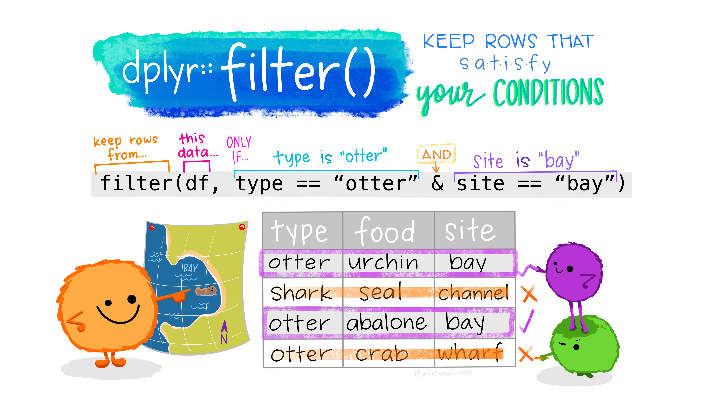

filter() function cartoon (from <https://github.com/allisonhorst/stats-illustrations>)

The filter() function is used to subset our data to only include certain rows. In the example above, I used it to only include cars with automatic transmissions (i.e. when the am variable was equal to 0). In general, our use of the filter function will look like:

filter(dataset_name, logical_condition, ...)

If we’ve used a pipe operator before filter() (like we saw above), we can leave off the first highlighted argument. After that, we just need to tell the function how to subset our data. For example, above I wrote am == 0. This meant that I wanted all the rows where am was 0. I can also use symbols like >, <, >=, <=, and != (see [Section 3.2 of the textbook](https://moderndive.com/3-wrangling.html#filter)).

If I want to have multiple conditions (e.g. automatic transmissions with 4 cylinders), I can add more conditions where the ... is. Just separate each condition with a comma. If you want to meet *at least one* of several conditions, you can put a | in between conditions instead of a comma.

Typically, we will want to store our new filtered data frame in an object using the assignment operator. Below is an example where I subset the mtcars data to only include automatic transmissions (where am is 0), so I call my new data frame auto.

auto <- filter(mtcars, am == 0)

**Practice**:

* Create a subset of our NC Bridges data that only includes bridges from Alamance County (call it alam_bridges)
* Create a subset that includes bridges that are structurally deficient (“SD”) and functionally obsolete (“SO”).
* Create a subset that includes bridges in Alamance County that are either structurally deficient OR functionally obsolete.

## Using select() to choose only certain columns

If we have more variables than we want in our data, we can use select() to remove some of them. In general, that might look like this:

select(dataset_name, variable_to_include, other_variable_to_include, ...)

Just like with filter(), we can omit the data set name if we use a pipe operator before select(). We can also ask for everything but a certain variable by putting a minus sign before the variable name. If we want several variables that are next to each other we can use the format variable_a:variable_b to return everything from variable_a to variable_b.

**Practice**:

* Update your alam_bridges data frame to only include ROUTE, ACROSS, YEARBUILT and SR

# Using mutate() to create new variables

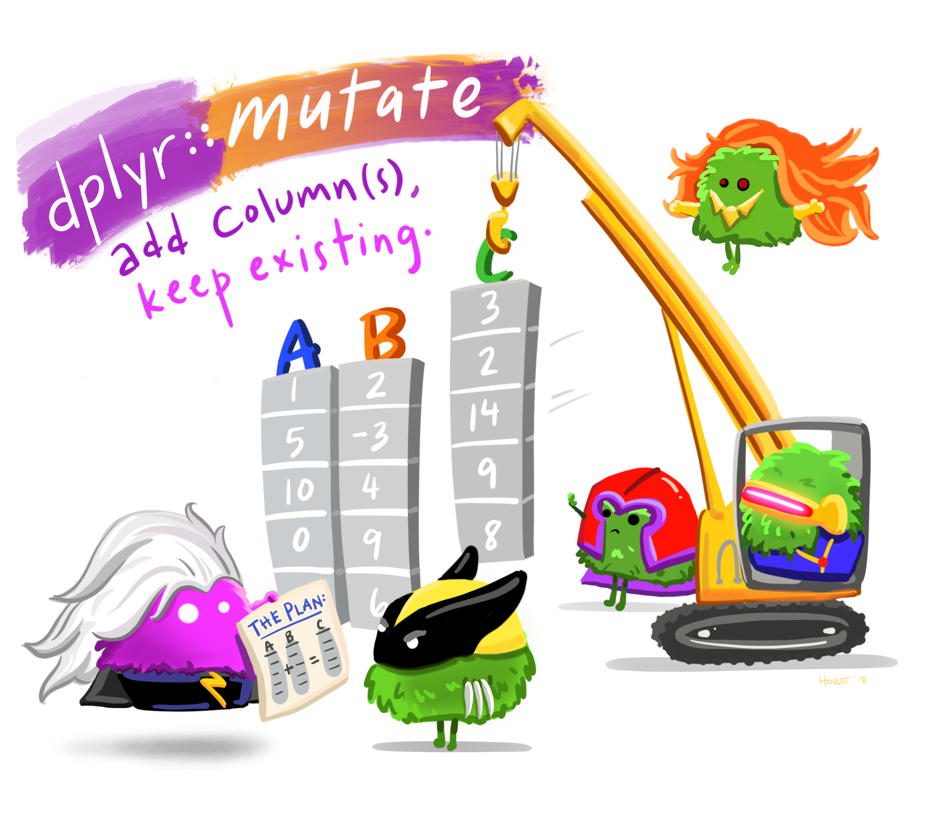

mutate() function cartoon (from <https://github.com/allisonhorst/stats-illustrations>)

In an example above, I used mutate() to convert the wt variable in mtcars (which records weight in thousands of pounds) into a new variable that calculates weight in pounds. Below is the general structure of the mutate() function followed by an example using mtcars.

mutate(dataset_name, newvar_name = calculation, ...)  
  
mycars <- mutate(mtcars, wt_lbs = wt * 1000)

My code used the mtcars data (dataset_name), created a new variable called wt_lbs, and calculated this as wt * 1000. Below I’m storing the result in a new data frame called mycars so I don’t edit the built in R data frame. (Note: If I wanted to create more than one variable, I could add other variables where the ... is.)

Let’s verify that this code did what I want…

mycars %>%  
 select(wt, wt_lbs) %>%  
 head(n = 5)

## wt wt_lbs  
## Mazda RX4 2.620 2620  
## Mazda RX4 Wag 2.875 2875  
## Datsun 710 2.320 2320  
## Hornet 4 Drive 3.215 3215  
## Hornet Sportabout 3.440 3440

**Practice**: Using the NC Bridges data, create a new variable called AGE that takes 2023 minus YEARBUILT. Then print the year built and age for the last 10 bridges in the data.

# Long vs. Wide Data

Our textbook calls long data (“tidy data”) and wide data (“non-tidy data”) (see [Section 4.2 of ModernDive](https://moderndive.com/4-tidy.html#tidy-data-ex)). In many cases, wide data is nicer for humans to look at, but long data is nicer for computers to interact with. The distinction will become more clear when we start visualizing data.

Below I’ve read in the exact same data stored in each format. The data represents the number of baby birds that were raised in nest boxes at the [Museum of Life + Science](https://www.natureblog.org/final-nest-box-update-8-1-23/) in Durham, NC. To save space, I’m only displaying the first and last 3 rows of the long data.

birds_wide <- read.csv("https://raw.githubusercontent.com/nbussberg/STS2300-Fall2024/main/Data/nestbox_lands_wide.csv")  
birds_long <- read.csv("https://raw.githubusercontent.com/nbussberg/STS2300-Fall2024/main/Data/nestbox_lands_long.csv")  
  
birds_wide

## Species X2012 X2013 X2014 X2015 X2016 X2017 X2018 X2019 X2020  
## 1 Eastern Bluebird 20 20 27 18 19 3 16 8 NA  
## 2 Carolina Chickadee 6 13 3 7 6 9 12 0 NA  
## 3 House Wren 0 0 0 0 0 11 5 4 NA  
## X2021 X2022 X2023  
## 1 5 17 13  
## 2 0 4 14  
## 3 5 3 9

head(birds_long, n = 3)

## Year Species Fledged  
## 1 2012 Eastern Bluebird 20  
## 2 2012 Carolina Chickadee 6  
## 3 2012 House Wren 0

tail(birds_long, n = 3)

## Year Species Fledged  
## 34 2023 Eastern Bluebird 13  
## 35 2023 Carolina Chickadee 14  
## 36 2023 House Wren 9

**Question:** Why do you think each of the years in birds_wide starts with an X?

**Answer:**

We can use the pivot_wider() and pivot_longer() functions from the tidyr packages to switch between formats (if we don’t already have both like this example). Let’s start by converting birds_wide to a long format.

In the code below, I’m piping my birds_wide data frame into the pivot_longer() function as the first argument. After that:

* cols = -Species says we will convert all of the columns other than species
* names_to = "Year" says that column names will go in a variable called Year
* values_to = "Fledged" says that the values within those columns will go into a variable called Fledged.

To save space, I’m using head() to only display the first five rows of my new long data frame. Notice how the year values match the first five columns from our wide data and the values match the first row (where Species was Eastern Bluebird).

library(tidyr)  
  
birds_wide %>%  
 pivot_longer(cols = -Species, names_to = "Year", values_to = "Fledged") %>%  
 head(5)

## # A tibble: 5 × 3  
## Species Year Fledged  
## <chr> <chr> <int>  
## 1 Eastern Bluebird X2012 20  
## 2 Eastern Bluebird X2013 20  
## 3 Eastern Bluebird X2014 27  
## 4 Eastern Bluebird X2015 18  
## 5 Eastern Bluebird X2016 19

There are still some issues with the Year column, but we could solve those as we learn more about R later.

To go from long to wide format, we use pivot_wider(). In the code below, I’m piping birds_long into the first argument of my pivot_wider() function and then: - names_from = Year says to make column names out of the Year variable - values_from = Fledged says to fill in the data tieh values from the Fledged variable.

birds_long %>%  
 pivot_wider(names_from = Year, values_from = Fledged)

## # A tibble: 3 × 13  
## Species `2012` `2013` `2014` `2015` `2016` `2017` `2018` `2019` `2020` `2021`  
## <chr> <int> <int> <int> <int> <int> <int> <int> <int> <int> <int>  
## 1 Eastern… 20 20 27 18 19 3 16 8 NA 5  
## 2 Carolin… 6 13 3 7 6 9 12 0 NA 0  
## 3 House W… 0 0 0 0 0 11 5 4 NA 5  
## # ℹ 2 more variables: `2022` <int>, `2023` <int>

At the top of this section, I linked to more examples of going between wide and long data in our ModernDive textbook. You can also find examples in [Sections 5.3 and 5.4 of R for Data Science](https://r4ds.hadley.nz/data-tidy#sec-pivoting) and [Section 6.2 of Modern Data Science with R](https://mdsr-book.github.io/mdsr3e/06-dataII.html#reshaping-data).

# Revisiting the Learning Goals for Notes 03

* Be able to use R Studio to generate code for importing data of various types into R.
  + There are several data sets in the data folder on our Moodle page. Try reading one of the Excel files into R.
* Understand the usefulness of the pipe operator and be able to write multi-step code using it.
  + What phrase do we use when reading the %>% symbol in our code?
* Be able to subset data frames by rows and columns as desired.
  + Create a subset of the mtcars data that only includes cars that get over 25 mpg and are manual transmission
  + Create a subset of the mtcars data that only includes the mpg, am, cyl, and wt variables
  + Combine the two steps above with a pipe operator and sort the data by mpg (Hint: Use arrange() from the example at the top.)
* Be able to create new variables to add to a data frame.
  + Using the birds_wide data, create a variable called Total that adds up the number of species from all of the years. (Note: Remember that NAs can’t be included in this)
  + Using the Loblolly data, convert the height variable from feet to meters. (Note: You can divide feet by 3.281 to get meters)
* Understand the difference between wide and long format data and be able to convert between the two types.
  + Is the MTH_STS_Majors (on Github) data set wide or long format? How do you know? Convert it to the opposite format.